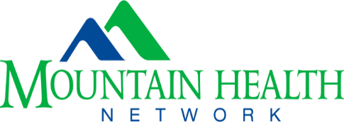

MOUNTAIN HEALTH NETWORK, INC. (MHN) TUITION ASSISTANCE APPLICATION FORM

PLEASE refer to MHN Tuition Assistance Policy

NAME: | DATE:
MAILING ADDRESS: | PHONE and E-MAIL address:
SCHOOL NAME: | SCHOOL ADDRESS:
PROGRAM: | PROGRAM LENGTH (specify 2 or 4 year):
PROGRAM DIRECTOR NAME: | PROGRAM DIRECTOR PHONE & EMAIL:
SEMESTER(S) REQUESTING TUITION ASSISTANCE: | PROJECTED GRADUATION DATE:

All items below must be included for the application to be considered complete unless stated otherwise:

____ Resume

____ College Transcript

____ Letter from applicant stating why the applicant wishes to be considered for the tuition assistance award

____ Proof of enrollment (such as printed schedule/dates of classes)*

____ Proof of cost (includes tuition and fees)*
*Proof of cost and enrollment documents must identify the school term, name of institution and employee’s name. These two items are not required for students in St. Mary’s School of Medical Imaging, Respiratory, or Nursing.

If attending St. Mary’s School of Medical Imaging, Respiratory, or Nursing please submit above application documents to Dr. Trader, Vice President, Schools of Nursing and Health Professions
Email address: Joseph.Trader@st-marys.org
For all other programs please submit documentation to Sara James, Recruitment Specialist
Email address: Sara.James@mhnetwork.org

By signing below, you attest that you have read and understand the MHN tuition assistance program policy and therefore understand that if you are chosen as a recipient of funds under this program that you will be required to commit to an employment term within Mountain Health Network as set forth more fully in the Tuition Assistance Program policy. Length of employment term will be specified in your tuition assistance agreement.

Applicant Signature Date

